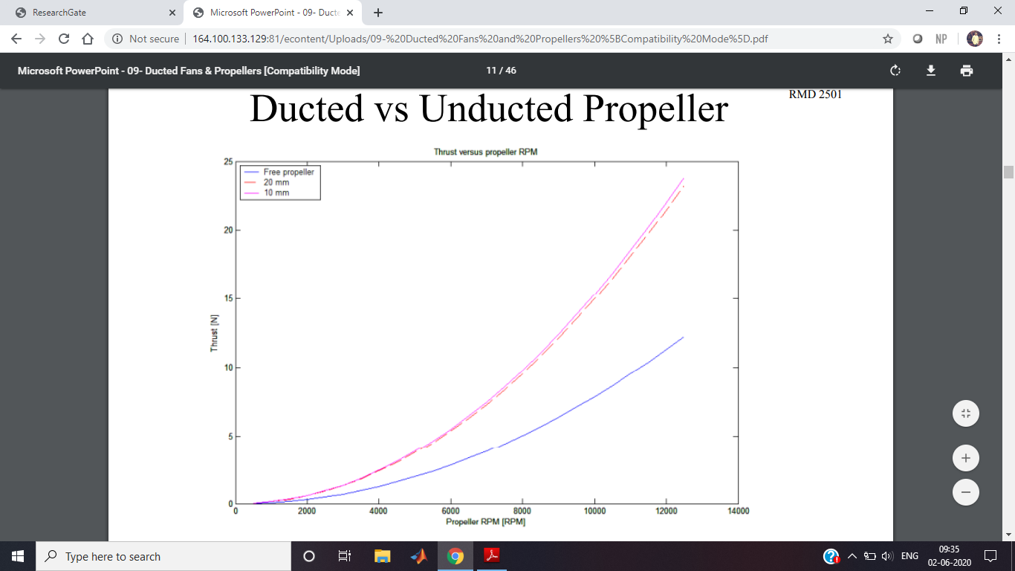

An EDF Brushless ESC regulates the power from the batteries to the motor. It must be properly selected in order to be able to handle the current draw demanded from the motor. It is recommended to choose a high quality ESC. The most common ESC is the ICE, ICE HV and ICE LITE series by Castle Creations. For the most part these high voltage and low voltage ESC’s will handle the majority of setups. Be sure the motor selected will not exceed the maximum continuous current rating of the ESC. If it does a higher rated ESC is needed. If you are using an ESC that has a linear BEC and you are planning to use more than 4s LiPo, it may be necessary to disconnect the BEC on the ESC and use a 4 or 5 cell NiMh receiver pack or 2 cell LiPo with voltage regulator.

This will be specified in the ESC manual whether this is required or not. To disconnect BEC remove the center wire on the ESC to RX lead. It can be pushed out with a pin and replaced later if needed.

Follow motor manufactures recommendations for motor timing. If unknown, keep low. For example Neu 1D motors must always be set for low timing.

Voltage cut off is standard at 3.0v per cell. However, if the power setup you are using does not draw a lot of power it’s recommend raising this value higher in order to stop a run a bit earlier leaving some capacity in the pack.  In most cases many raise this cutoff to at least 3.2v per cell.

Generally, most EDF units will run between 30000 RPM and 50000 RPM

Hand Launching

Hand Launching is generally limited to a plane constructed out of foam. Wing Loading should be less than 20oz/sq ft. A higher wing loading will launch easier with higher power. Under powered EDF jets will be more difficult to launch. Be sure to double check that your Center of Gravity is correct and run over all pre-flight checks. An incorrect Center of Gravity for a first launch may be your last.

Before hand launching it is necessary to find the positioning of how you want to hold the plane and your tossing motion. Practicing without releasing the plane may help. Generally, holding the plane just behind the center of gravity is ideal. Many prefer to have the plane right side up with an overhand style toss. However, there are a couple different variations that may work better. An under hand toss holding the top of the plane so that it is right side up may feel better. Some planes even have an inverted preferred hand launch. Select the variation that you are most comfortable with.

To hand launch face the wind. A friend may be best if you are not comfortable launching alone. Aim the airplane at a 25 degree climb angle. It is often best to use Wide Open Throttle during a hand launch. Unlike prop planes, torque roll is not as significant. With the plane aimed for 25 degree climb out and throttle is wide open, firmly toss the plane forward. A firm launch in to the wind is required to get the plane up to speed. Maintain full throttle and transition from throwing the plane to grabbing the control sticks as quickly as possible. EDF jets do not have prop wash passing over the control surfaces. The plane after launch will not yet be up to a comfortable flying speed and may dip back down. Carefully bring the plane up to a safe altitude before making the first turn and trimming out.

